CHAPTER 1
INTRODUCTION

1.1 Introduction
Food waste is a major problem in society, while many people and communities still face difficulties in accessing sufficient food. Restaurants, hotels, hostels, college canteens, and individuals often have surplus food that may remain unused and eventually become waste. At the same time, NGOs and volunteers can help redistribute suitable surplus food to people in need, but the process is often handled manually and lacks proper coordination.
FoodRescue – Smart Surplus Food Redistribution & Rescue Coordination Platform is a web-based application developed using the MERN Stack, which consists of MongoDB, Express.js, React.js, and Node.js. The system provides a common platform for donors, NGOs, volunteers, and administrators to coordinate the collection and redistribution of surplus food.
The platform allows donors to register available surplus food by providing details such as food name, quantity, food type, preparation time, pickup deadline, and location. NGOs can view available food donations and accept suitable donations. Volunteers can be assigned to collect the food from the donor and deliver it to the respective NGO.
The system also maintains the status of every donation from creation to successful delivery. By connecting donors, NGOs, and volunteers through a single platform, FoodRescue aims to make surplus food redistribution more organized, efficient, and transparent.

1.2 System Overview

FoodRescue consists of four major user roles:

Donor – Adds and manages surplus food donations.

NGO – Views and accepts available food donations.

Volunteer – Handles pickup and delivery of accepted donations.

Admin – Manages users, NGOs, volunteers, and donations.

The main workflow of the system is:
Donor → Food Donation → NGO Acceptance → Volunteer Assignment → Pickup → Delivery → Completed Donation
The frontend of the application is developed using React.js, while Node.js and Express.js are used to develop the backend REST APIs. MongoDB is used to store user, donation, NGO, volunteer, and assignment information.
CHAPTER 2

METHODOLOGY

2.1 Objective

The main objective of the FoodRescue project is to develop a web-based platform for efficiently coordinating surplus food redistribution.

The specific objectives are:
- To provide a platform for donors to register and share surplus food.
- To allow NGOs to view and accept available food donations.
- To connect volunteers with food pickup and delivery tasks.
- To maintain food donation and delivery status digitally.
- To reduce manual coordination between donors, NGOs, and volunteers.
- To store donation and user information securely using MongoDB.
- To provide role-based access for donors, NGOs, volunteers, and administrators.
- To develop a user-friendly and responsive web application using the MERN Stack.
- To provide basic smart matching based on factors such as location, capacity, and availability.
- To improve the overall organization and transparency of the food redistribution process.
2.2 Problem Statement
Surplus food from restaurants, hotels, hostels, college canteens, and individuals is often wasted because there is no proper system to quickly connect food donors with organizations that can redistribute the food.
The existing process may involve phone calls, messages, or manual coordination between donors, NGOs, and volunteers. This can result in delays, lack of information, difficulty in tracking donations, and inefficient volunteer coordination.
Therefore, there is a need for a centralized digital platform that can:
- Connect food donors with NGOs.
- Display available surplus food.
- Manage donation information.
- Coordinate volunteers.
- Track pickup and delivery.
- Maintain donation status.
- Provide centralized data management.
2.3 Project Description
FoodRescue – Smart Surplus Food Redistribution & Rescue Coordination Platform is a MERN Stack-based web application developed to manage the redistribution of surplus food from donors to NGOs with the support of volunteers.
The system provides separate interfaces for Donors, NGOs, Volunteers, and Admin. Donors can register surplus food by entering food details, quantity, food type, preparation time, pickup deadline, and pickup location. These details are stored in the MongoDB database through the Node.js and Express.js backend.
Registered NGOs can view available food donations and accept suitable donations based on their requirements. Once a donation is accepted, a volunteer can be assigned to collect the food from the donor and deliver it to the NGO. The donation status is updated throughout the process, such as Available, Accepted, Assigned, Picked Up, Out for Delivery, and Delivered.
The system also provides a basic smart matching mechanism that considers factors such as location, food quantity, NGO capacity, pickup deadline, and volunteer availability to recommend suitable matches.
Major Modules
1. Authentication Module
Provides registration, login, JWT authentication, and role-based access.
2. Donor Module
Allows donors to create, manage, and track surplus food donations.
3. NGO Module
Allows NGOs to view available donations, accept suitable food, and monitor deliveries.
4. Volunteer Module
Allows volunteers to view assigned tasks and update pickup and delivery status.
5. Admin Module
Allows administrators to manage users, NGOs, volunteers, and donations.
6. Donation Management Module
Maintains food details, quantity, location, deadline, and current donation status.
7. Smart Matching Module
Provides basic recommendations based on location, capacity, quantity, availability, and deadline.

CHAPTER 3

RESULTS AND DISCUSSION

The FoodRescue application was successfully designed as a MERN Stack web application to manage surplus food donation and redistribution. The system provides separate functionalities for donors, NGOs, volunteers, and administrators.

The developed application allows users to register and login based on their roles. Donors can create food donations, NGOs can view and accept available donations, and volunteers can manage pickup and delivery activities. The system stores the application data in MongoDB and communicates between the frontend and backend through REST APIs.

The major screens of the developed application are shown below

Screenshots
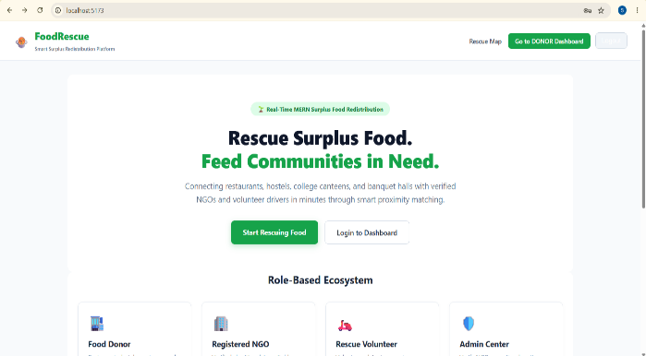Figure 3.1 The landing page provides an introduction to the FoodRescue platform and allows users to access the login and registration pages. | 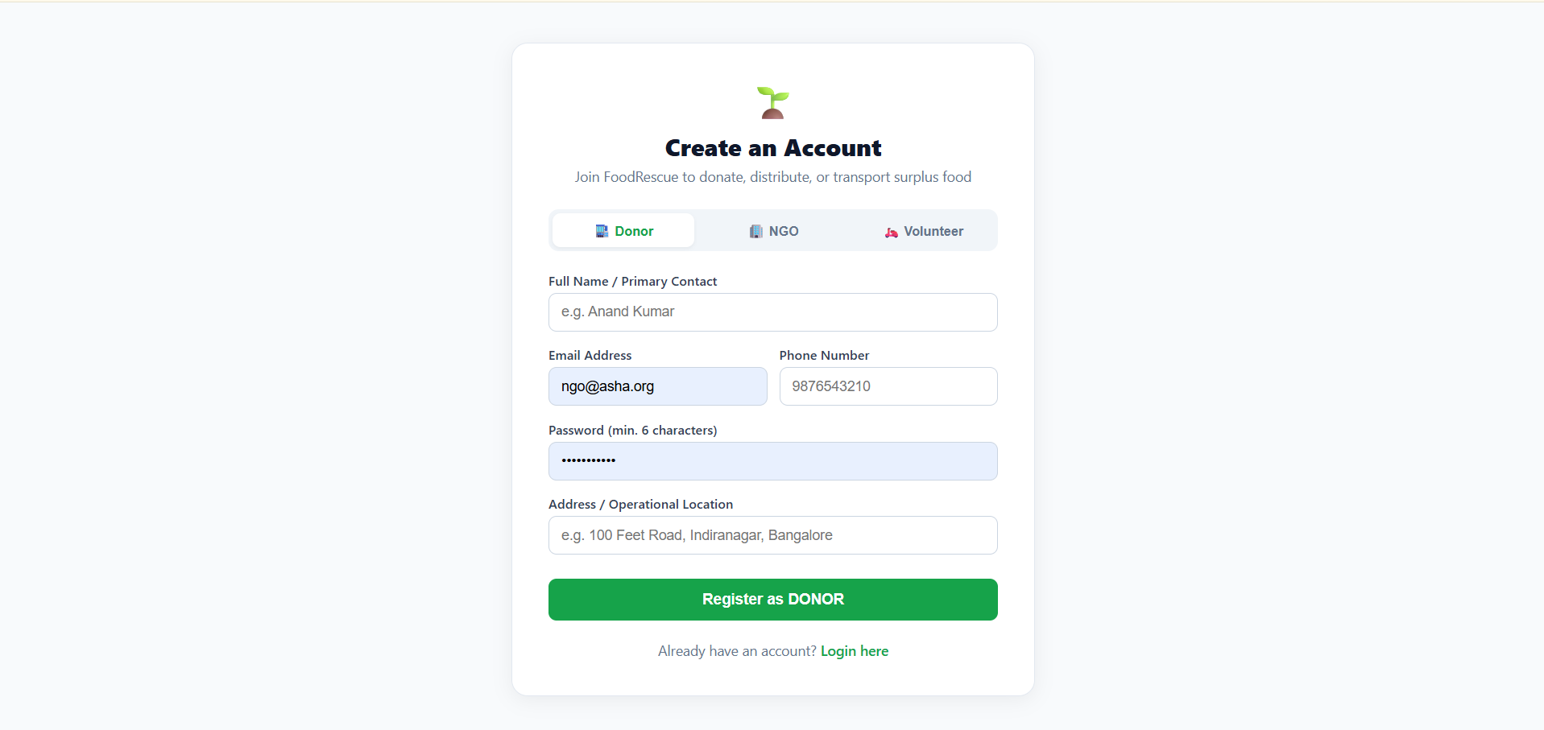Figure 3.2 The registration page allows users to create an account by entering their basic details and selecting their appropriate role.

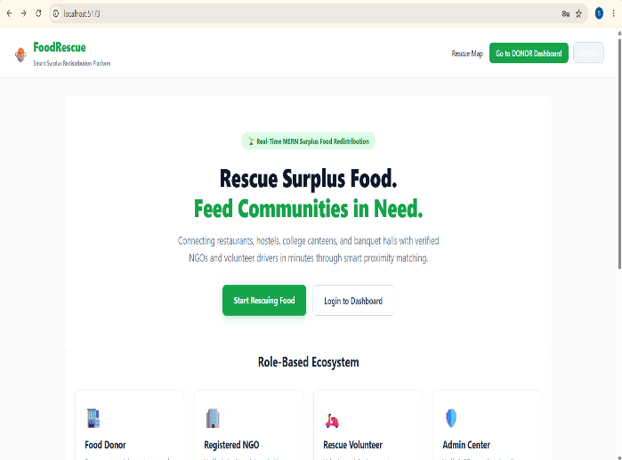Figure 3.1 The landing page provides an introduction to the FoodRescue platform and allows users to access the login and registration pages. | Figure 3.2 The registration page allows users to create an account by entering their basic details and selecting their appropriate role.
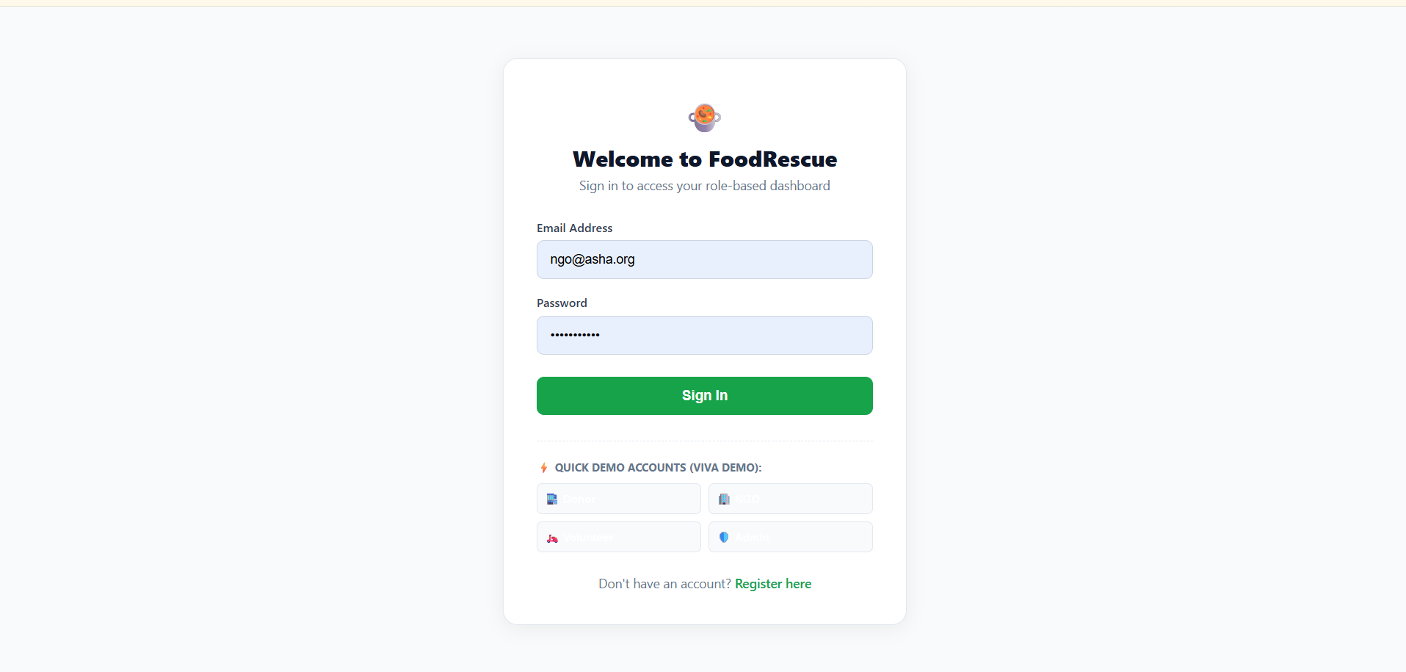Figure 3.3 The login page authenticates registered users and redirects them to their respective dashboards based on their role. | 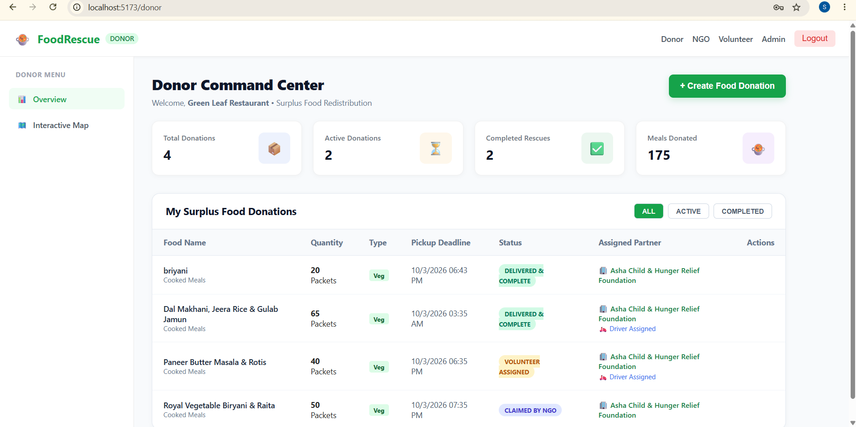Figure 3.4 The donor dashboard displays donation statistics and provides options to create and manage surplus food donations.
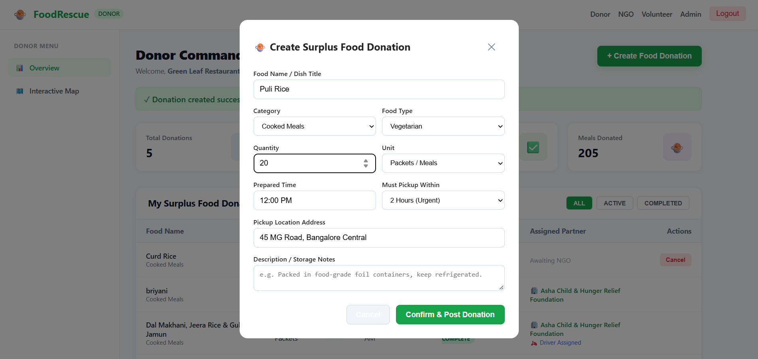Figure 3.5 The donation form allows the donor to enter food name, category, quantity, food type, preparation time, pickup deadline, location, and description. | 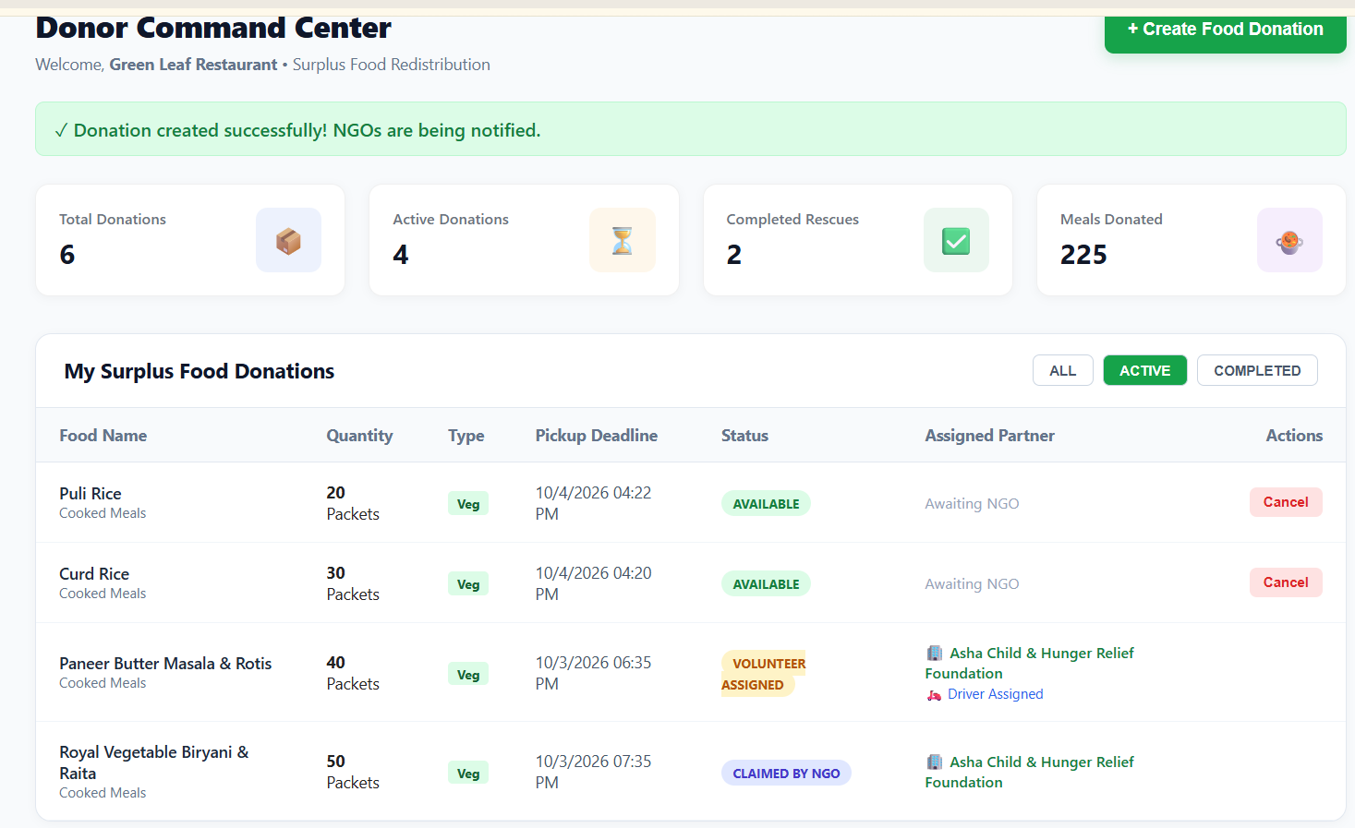Figure 3.6 This page displays the donations created by the donor along with their current status.
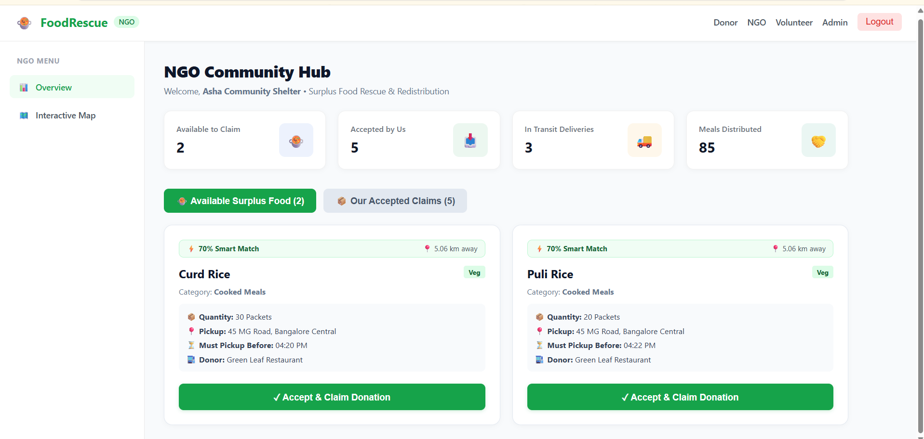Figure 3.7 The NGO dashboard displays available food donations and accepted donations that can be managed by the organization. | 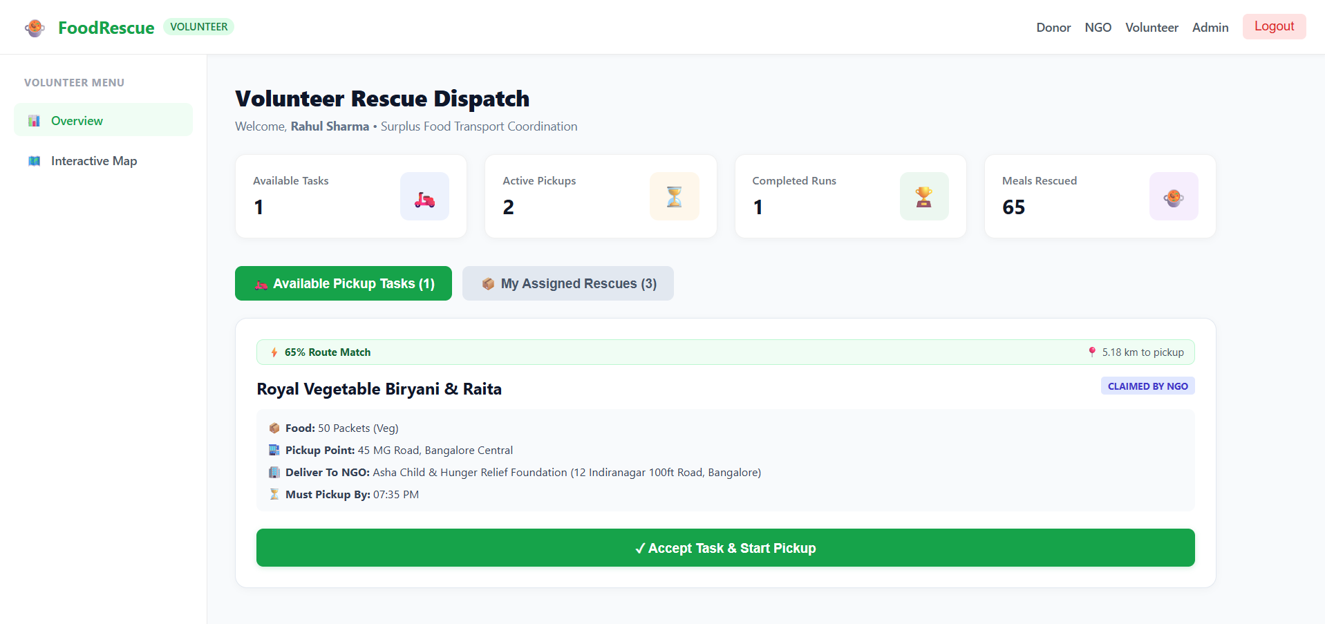Figure 3.8 The volunteer dashboard displays assigned food pickup and delivery tasks along with their current status.
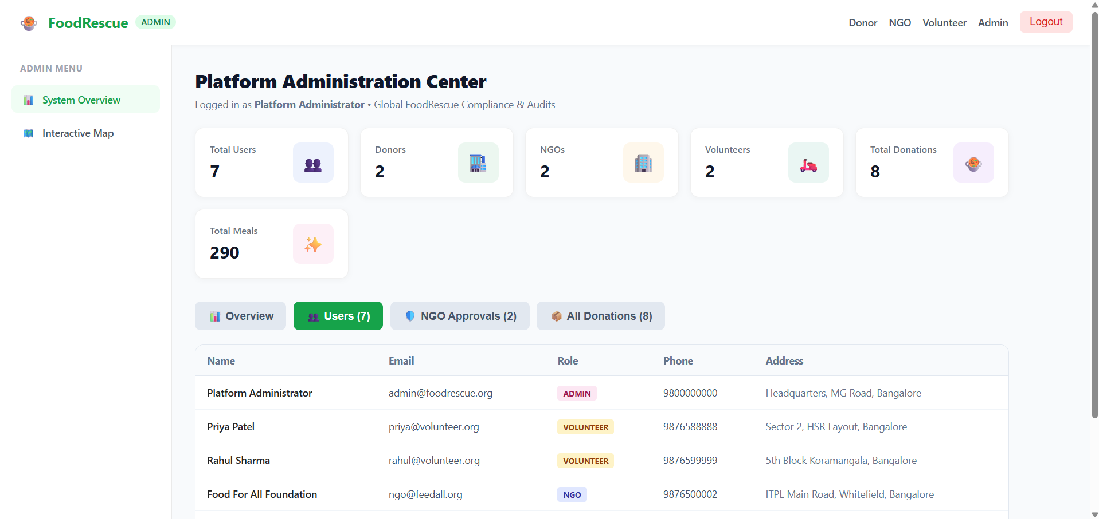Figure 3.9 The admin dashboard provides an overview of users, donations, NGOs, volunteers, and overall system activity. | 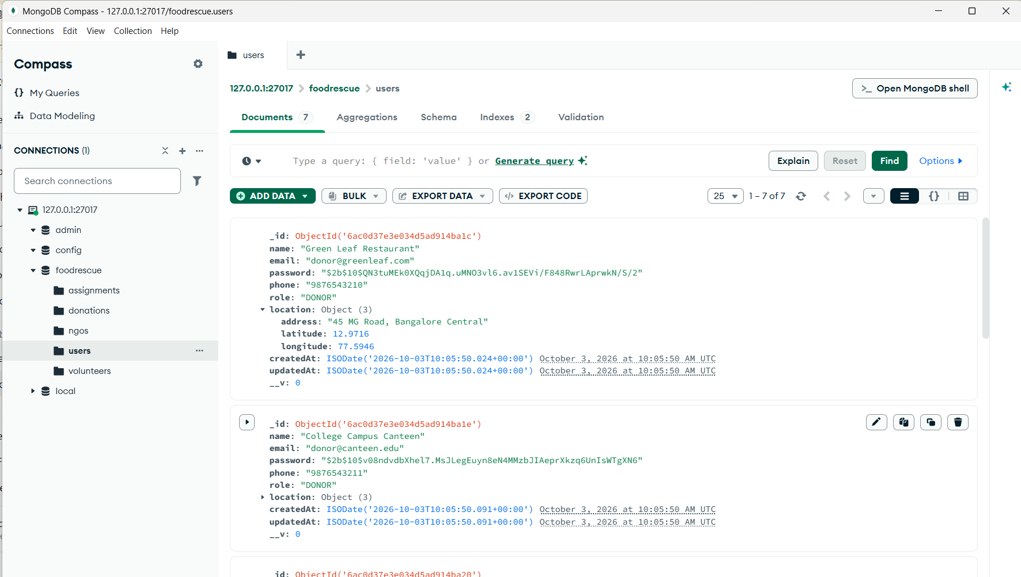Figure 3.10 The MongoDB database stores user, donation, NGO, volunteer, and assignment information used by the application.

Github Link:

https://github.com/sonaeswari778607-hue/Smart-Surplus-Food-Redistribution-Rescue-Coordination-Platform

CHAPTER 4
CONCLUSION
The FoodRescue – Smart Surplus Food Redistribution & Rescue Coordination Platform was developed as a MERN Stack-based web application to provide an organized solution for managing surplus food redistribution.
The system connects donors, NGOs, and volunteers through a centralized platform. Donors can register surplus food, NGOs can accept available donations, and volunteers can coordinate pickup and delivery. The application also maintains donation status and stores the required information in MongoDB.The project demonstrates the practical implementation of React.js, Node.js, Express.js, MongoDB, Mongoose, REST APIs, JWT authentication, and role-based authorization in a full-stack application.FoodRescue can help reduce unnecessary food wastage by making the process of identifying, coordinating, and redistributing surplus food more systematic. The project can also be extended in the future with advanced features such as real-time tracking, QR-based verification, notifications, advanced matching, and analytics.
Overall, the project demonstrates how a MERN Stack web application can be used to address a real-world social problem through digital coordination and centralized information management.

REFERENCES

- G. Ayesha Anzer, Hadeel A. Tabaza, and Wedad Ahmed, “A Food Wastage Reduction Mobile Application,” in 6th International Conference on Future Internet of Things and Cloud Workshops, 2018.
- K. Jayalakshmi S. Pavithra C. Aarthi, “Waste to Wealth- A Novel Approach for Food Waste Management,” in “7 International Conference on Electrical, Instrumentation and Communication Engineering ”, 2017.
- P. K. Rajvor et al., “Reduction of Food Wastage Through Donation Using Online Food Management System for Orphanage,” Int. J. Eng. Appl. Sci. Technol., vol. 5, no. 10, Feb. 2021, pp. 37–43.
- H. An et al., “Tackling Food Waste and Loss Through Digitalization in the Food Supply Chain,” Technological Forecasting and Social Change, 2025.
- Montero, R.P., 2025. Enhancing Food Bank Efficiency: A Web-Based Solution for Real-Time Inventory Management and Distribution Optimization ( Doctoral dissertation, Guilford College ).
- Ending hunger, saving food: Innovations for surplus redistribution for NGO's. In AIP Conference Proceedings (Vol. 3325, No. 1, p. 040020 ). AIP Publishing LLC.
- Dina Elkhattat, Mervat Medhat, “Using Technology in Smart and Intelligent Food Packages as a Communicational Tool with Consumers,” in “World Conference on Computing and Communication Technologies ”, 2021
- Grace Phiri, Pip Trevorrow, “Sustainable Household Food Management Using Smart Technology,” in “10h IEEE International Conference on Dependable Systems, Services and Technologies ”, 2019.
- Papargyropoulou, E., Fearnyough, K., Spring, C., & Antal, L. ( 2022 ). The future of surplus food redistribution in the UK: Reimagining a ‘win- win’scenario. Food Policy, 108, 102230.
- Kodera, Ryota, Takanori Sakai, and Tetsuro Hyodo. “Development of a Delivery Time-Period Selection Model for Urban Freight Using GPS Data.” Smart Cities 8, no. 1 ( 2025 ): 31.

